**OPTIMIZATION TECHNIQUES**

**ASSIGNMENT OF WEEK 1**

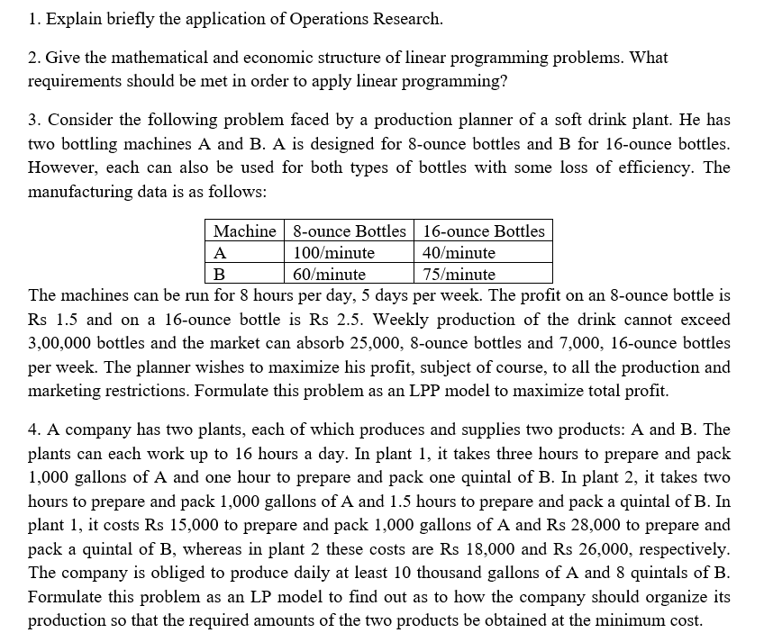

**ANSWER 1:**  
Operations Research (OR) is the study of optimization techniques. Decision making plays an important role in management process. Managerial decision making is a process by which the decision maker (DM), during a critical situation selects a most effective course of action from a set of possible alternatives in attaining the goals of the organization. A variety of real life  
problems have been given a quantitative representation with varying degrees of success and it has led to a general approach which is variedly designated as Operations Research, Management science, Systems analysis, Decision analysis, Decision Science and so on. We now discuss in extensive about historical development, nature and characteristic, methodology and advantages  
of OR  
2. Origin and development of Operations Research  
The term ‘Operations Research’ was framed first by McClosky and Trefthen in the year 1940.  
During World War II, military management called on scientists from various disciplines to discuss and suggest ways and to improve the execution of various military projects such as deployment of radar, management of bombing, convoy and mining operations . The systematic and scientific study of the operations of the system suggested by these scientists showed a remarkable progress. It helped to win the war with the limited resources. This new approach was called as Operations Research. Following the end of the World war, the success of military teams attracted the attention of industrial managers who were seeking solutions to their complex executive type problems.  
During the year 1950, OR achieved recognition as a subject worthy of academic study in the universities. With a view to increasing the impact of OR and establishing rapport between all its researchers, the Operation Research Society of America was formed in 1950 and in 1957 the International Federation of OR Societies was established.

3. Nature and Features of Operations Research  
The word “operations” may be defined as some actions that we apply to some problems and the word “research” is an organized process of seeking out facts about the same. Some commonly used definitions of OR are given below:  
“OR is a scientific approach to problems solving for executive management” – H.M.Wagner  
“OR is applied decision theory. It uses many scientific, mathematical or logical means to attempt to cope with the problems that confront the executive when he tries to achieve a thorough-going rationality in dealing with his decision problems”- D.W.Miller and M.K.Starr “OR is a scientific knowledge through interdisciplinary team effort for the purpose of determing the best utilization of limited resources- H.A.Taha.  
Some important features of OR are highlighted below:  
• Decision-making:  
It is primarily used in managerial decision making problems  
• Scientific approach:  
For solving problems OR employs different scientific methods.  
• Objective:  
The objective of OR is to attain the optimal solution to the problem under  
consideration.  
• Interdisciplinary team approach:  
OR is interdisciplinary in nature. Managerial problems have economic, physical,  
biological, psychological, sociological and engineering aspects.  
• Digital computer:  
Due to the complexity of OR models, for computation purpose the digital  
computers plays a very important role. Computer science and OR are interrelated from its origin. As computers can handle a large number of data it allows the researchers to build more realistic models involving more variables and constraints. By using simulation techniques, the computers help the decision maker to get a compromise solution to those larger models.  
4. Modeling in Operations Research  
Models in OR should have all features such as it should be simple, the number of variables used are less etc. The objective of a model is to analyze the system thoroughly to improve its performance of the problem under consideration. The validity of the models can be verified only by performing experiment and its data. A mathematical model will provide a relationship between constants and variables which is expressed as a mathematical equation. The decision variables, controlled variables and uncontrolled variables are the three basic components of a mathematical model. The two broad categories of mathematical models used in OR are deterministic models and probabilistic models.  
1. Deterministic models:  
A mathematical model in which all variables under consideration are treated as  
predetermined values so that the parameters of the models are precisely known is called a deterministic model.  
2. Probabilistic models:  
A mathematical model in which all variables under consideration are treated as  
random variables is called a probabilistic model or stochastic model. The  
parameters are uncertain in nature and are denoted by probabilistic values.  
5. General solution methods for OR models  
Different solution methods for OR models are available in literature. They are analytical  
methods, the numerical methods and the Monte-Carlo methods. In detail it is explained below.  
1. Analytical method:  
In solving OR models if the solutions are obtained by the classical optimization  
techniques such Calculus, Finite difference method etc., are called analytical  
methods.  
2. Numerical methods:  
If classical optimization techniques fails to obtain a solution due to complexity  
nature of the OR model, then we have to adopt numerical or iterative methods. In  
iterative methods, the procedure starts with an initial solution and we try to  
improve it. The procedure is repeated until further better solution is not possible.  
3. Monte-Carlo methods:  
Monte-Carlo method is a simulation technique in which Probability theory and  
sampling concepts are used.  
6. Methodology of OR  
The systematic methodology developed for an OR study deals with problems involving  
conflicting multiple objectives, policies and alternatives. The OR approach to problem solving  
consists of the following steps:  
 Step 1: Identifying the objectives, constraints and decision variables of the model.  
 Step 2: Expressing all variables of the model into a mathematical model.

Step 3: Obtaining the optimal solution of the model by using analytic method or iterative method or Monte-Carlo method.  
 Step 4: Validating the model by experience or from the past available data  
whether the model provides a better solution which can be adapted to real life  
situation.  
 Step 5: Establishing control over the solution of the model, as the solution which  
is optimum today might change due to the occurrence of new variables . This  
helps in finding the limits within which the model and its solution can be  
considered reliable.  
 Step 6: Implementing the solution to achieve the desired goal.

METHODOLOGY OF OPERATION RESEARCH  
Design the problem  
Construction of a mathematical model  
Obtaining the solution from the model  
Validating the model  
Establishing control over the solution  
Implementation of the final results

7. Applications of OR  
In recent years, OR plays a major role in many different areas of business and  
management which is briefly explained below:  
1. Marketing:  
• Product selection  
• Competitive strategies  
• Advertising strategies  
2. Production management:  
• Project scheduling  
• Allocation of resources  
• Location of factories and their sizes  
• Equipment replacement and Maintenance  
• Inventory policy  
3. Finance management:  
• Cash flow analysis  
• Capital requirement  
• Credit policies  
4. Personal management:  
• Recruitment policies  
• Assignment of jobs  
5. Purchasing and procurement:  
• Roles for purchasing  
• Determining the quantity  
6. Distribution:  
• Location of warehouses  
• Transportation strategies  
7. Agriculture:  
• Distribution of water to lands  
• Allocation of land to crops  
8. Research and development:  
• Selection of projects  
• Determination of the areas of Research and Development  
Finally, we can say: wherever there is a decision making problem, there is OR.

8. Short coming of Operations Research:  
In real life situation framing of mathematical models do not consider qualitative or emotional  
human factors which are quite real and influence the decision making. These influencing factors  
find no place in OR. This is the main limitation of OR.  
9. Introduction to Linear programming problem:  
A linear programming problem (LPP) is a problem which determines the optimal allocations of limited resources to meet the goal of the objectives. It deals with the optimization of a function of decision variables known as objective function, subject to a set of simultaneous linear equations or inequalities known as constraints. Here optimization may refer to maximization or minimization of the objective function. The term “Linear” means that all the variables occurring in objective function and the constraints are of the first degree in the problems under consideration and the term “Programming” means the process of determining a particular course of action.  
The following are the requirements needed for LPP technique:  
 The objective function of the problem must be well defined.  
 The alternative course of action must be available for selection.  
 Constraints are constructed based on limited available resources.  
 Both the objective function and constraints must be linear equations or inequalities.  
The three important components of a LPP model are the decisional variables, the objective function and the constraints.  
Components of LPP model  
Decision variables  
Objective function Constraints

• Assumptions of an LPP Model  
The following assumptions are made while framing LPP model:  
 Certainty:  
All the parameters of LPP model are assumed to be certain. For example  
cost, availability of resources and demand etc., are known precisely and  
denoted by constants.  
 Additivity:  
Total amount of each resource used must be equal to the value of objective  
function. For example, the total profit obtained by selling two products X  
and Y must be equal to the sum of the profits earned individually from X  
and Y.  
 Proportionality:  
The amount of each resource used and its contribution to the profit in  
objective function must be proportional to the value of each decision  
variables. For example, if production time of a product X using a  
particular resource takes 20min, then production time for 3 units of  
product X takes one hour. That is if resource availability increases by  
some percentage then the output shall also increase by the same  
percentage.  
 Divisibility:  
The solution values of decision variables are not restricted to integer  
values. For example, it is possible to have 5.5 kg of rice in a farming  
problem and such variables are divisible. But it is not desirable to produce  
2.5 men and such variables are not divisible.

• Advantages of LPP model  
Some advantages of LPP model are stated below:  
 LPP model provides an insight and perspective in to the decision making  
problem environment and makes a scientific and mathematical analysis of  
the problem situations.  
 Linear programming approach helps the decision maker to reach the goal  
and improves the quality of decision.  
 LPP model deals with changing situations. Once a plan is arrived through  
the linear programming it can also be revaluated for changing conditions  
and the decision maker makes sure that he is considering the best solution.

• Disadvantages of LPP model  
Some disadvantages of LPP model are stated below:  
 The main drawback of LPP model is that it assumes all relationships as  
linear. But in real life problems the components of LPP model are not  
linear.  
 The decision variables in some LPP would be meaningful only if they  
have integer values. But while solving LPP model we may end with the  
solution of decision variables as fractional values where only integer  
values are meaningful.  
 LPP model deals with only single objective functions either maximize or  
minimize. But in real life situation, there may be more than one objective  
functions to be considered.  
 All parameters in the LPP model are assumed to be known constants. But  
in real life they may not be known completely or uncertain.  
10. Mathematical formulation of LPP  
The general mathematical model of a LPP is defined as follows:  
Let j (j=1,2,...,n)x represents ‘ n ’decision variables and the system has ‘ m ’constraints.  
Optimize (Maximize or Minimize) 1 2  
( )  
n  
Z f x ,x ,...,x= (called Objective function)  
Subject to 1 2  
( ) , =, b ( 1 2 m)  
i n i  
g x ,x ,...,x i , ,...,≤ ≥ = (called constraints)  
And 1 2 0  
n  
x ,x ,...,x ≥ (called non-negativity restriction)  
The procedure for forming a LPP model is given below:  
 Step 1: Identify the decision variables of the model and designate them by  
symbols like j (j=1,2,...,n)x .  
 Step 2: Identify the restrictions or constraints and express them as linear  
inequalities or equations.  
 Step 3: Identify the goal or objective and express it as linear equation of decision  
variables.  
 Step 4: State the feasible alternatives such as non-negativity condition  
1 2 0  
n  
x ,x ,...,x ≥

Some points to be noted while formulating the LPP.  
• In LPP the decision maker usually wants to maximize revenue or maximize Profit  
and minimize cost functions of decision variables.  
• For a constraints or restrictions all terms in them must have the same units.  
• For making proper inequalities or equalities in constraints the following situations  
will help the reader. Usage of manpower, time, raw materials are always less than  
or equal to the availability of manpower, time, raw materials etc. Production is  
always greater than or equal to the requirement so as to meet the demand.  
11. Examples  
Example 1: (Production allocation problem)  
A company manufactures two types of products X and Y and sells them to customers at a  
profit of Rs.2 on X and Rs. 3 on Y. Each product is processed on two machines A and B.  
Product X requires 1 minute and 2 minutes of processing time on machines A and B  
respectively. Product Y requires 1 minute of processing time on both machines A and B.

**ANSWER 2:**

A linear programming problem (LPP) is a problem which determines the optimal allocations of limited resources to meet the goal of the objectives. It deals with the optimization of a function of decision variables known as objective function, subject to a set of simultaneous linear equations or inequalities known as constraints. Here optimization may refer to maximization or minimization of the objective function. The term “Linear” means that all the variables occurring in objective function and the constraints are of the first degree in the problems under consideration and the term “Programming” means the process of determining a particular course of action.  
The following are the requirements needed for LPP technique:  
 The objective function of the problem must be well defined.  
 The alternative course of action must be available for selection.  
 Constraints are constructed based on limited available resources.  
 Both the objective function and constraints must be linear equations or inequalities.  
The three important components of a LPP model are the decisional variables, the objective function and the constraints.  
Components of LPP model  
Decision variables  
Objective function Constraints

• Assumptions of an LPP Model  
The following assumptions are made while framing LPP model:  
 Certainty:  
All the parameters of LPP model are assumed to be certain. For example  
cost, availability of resources and demand etc., are known precisely and  
denoted by constants.  
 Additivity:  
Total amount of each resource used must be equal to the value of objective  
function. For example, the total profit obtained by selling two products X  
and Y must be equal to the sum of the profits earned individually from X  
and Y.  
 Proportionality:  
The amount of each resource used and its contribution to the profit in  
objective function must be proportional to the value of each decision  
variables. For example, if production time of a product X using a  
particular resource takes 20min, then production time for 3 units of  
product X takes one hour. That is if resource availability increases by  
some percentage then the output shall also increase by the same  
percentage.  
 Divisibility:  
The solution values of decision variables are not restricted to integer  
values. For example, it is possible to have 5.5 kg of rice in a farming  
problem and such variables are divisible. But it is not desirable to produce  
2.5 men and such variables are not divisible.  
• Advantages of LPP model  
Some advantages of LPP model are stated below:  
 LPP model provides an insight and perspective in to the decision making  
problem environment and makes a scientific and mathematical analysis of  
the problem situations.  
 Linear programming approach helps the decision maker to reach the goal  
and improves the quality of decision.  
 LPP model deals with changing situations. Once a plan is arrived through  
the linear programming it can also be revaluated for changing conditions  
and the decision maker makes sure that he is considering the best solution.

• Disadvantages of LPP model  
Some disadvantages of LPP model are stated below:  
 The main drawback of LPP model is that it assumes all relationships as  
linear. But in real life problems the components of LPP model are not  
linear.  
 The decision variables in some LPP would be meaningful only if they  
have integer values. But while solving LPP model we may end with the  
solution of decision variables as fractional values where only integer  
values are meaningful.  
 LPP model deals with only single objective functions either maximize or  
minimize. But in real life situation, there may be more than one objective  
functions to be considered.  
 All parameters in the LPP model are assumed to be known constants. But  
in real life they may not be known completely or uncertain.  
10. Mathematical formulation of LPP  
The general mathematical model of a LPP is defined as follows:  
Let j (j=1,2,...,n)x represents ‘ n ’decision variables and the system has ‘ m ’constraints.  
Optimize (Maximize or Minimize) 1 2  
( )  
n  
Z f x ,x ,...,x= (called Objective function)  
Subject to 1 2  
( ) , =, b ( 1 2 m)  
i n i  
g x ,x ,...,x i , ,...,≤ ≥ = (called constraints)  
And 1 2 0  
n  
x ,x ,...,x ≥ (called non-negativity restriction)  
The procedure for forming a LPP model is given below:  
 Step 1: Identify the decision variables of the model and designate them by  
symbols like j (j=1,2,...,n)x .  
 Step 2: Identify the restrictions or constraints and express them as linear  
inequalities or equations.  
 Step 3: Identify the goal or objective and express it as linear equation of decision  
variables.  
 Step 4: State the feasible alternatives such as non-negativity condition  
1 2 0  
n  
x ,x ,...,x ≥

Some points to be noted while formulating the LPP.  
• In LPP the decision maker usually wants to maximize revenue or maximize Profit and minimize cost functions of decision variables.  
• For a constraints or restrictions all terms in them must have the same units.  
• For making proper inequalities or equalities in constraints the following situations  
will help the reader. Usage of manpower, time, raw materials are always less than  
or equal to the availability of manpower, time, raw materials etc. Production is  
always greater than or equal to the requirement so as to meet the demand.